CVI Registration Card Guidance
(England, Wales and Northern Ireland)

When an individual becomes certified as sight impaired or severely sight impaired a Certificate of Vision Impairment is issued. A copy of this certificate will be sent to the local authority, health and social care trust or their representatives. Department of Health Guidance (2017) states: “on receipt of a CVI, in addition to providing an assessment of the patient’s social care needs, the local authority or an organisation working on their behalf should also contact the patient to offer and explain the benefits of registration. Registration is voluntary, and whilst it is essential to obtain some benefits and concessions, it is not a prerequisite for accessing support from social services.”
RWPN has become aware from its members that there is some uncertainty over the status of the registration cards that are also available as part of the process. The purpose of this document is to offer some further guidance around registration cards.
When the CVI document itself was updated in 2018, the guidance accompanying it contains the following statement:

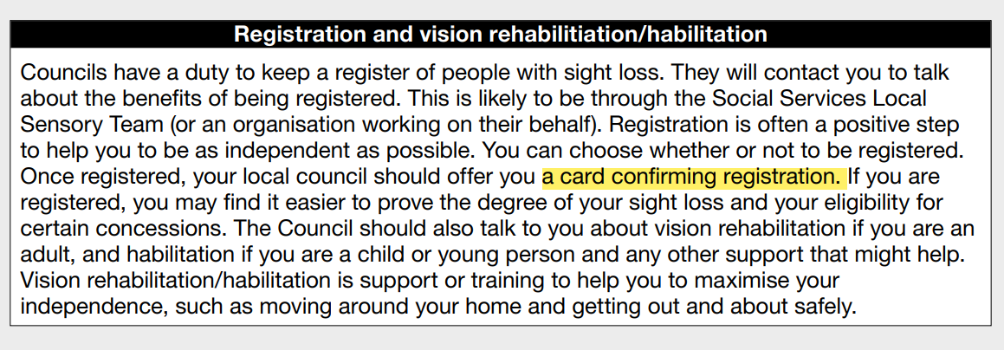

Highlighted in yellow, it states that a card confirming registration will be given as a means of offering confirmation that someone is registered. However, feedback to RWPN indicates that this does not seem to be happening in all areas.
The updated CVI document of 2018 does make it clear that registration should be confirmed by the offering of a card. However, there is no official guidance as to what the card must look like or contain so the content seems to be up to each registering body that issues a card.
Below are some examples that are being used now with adults and children:

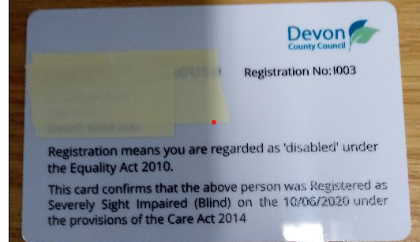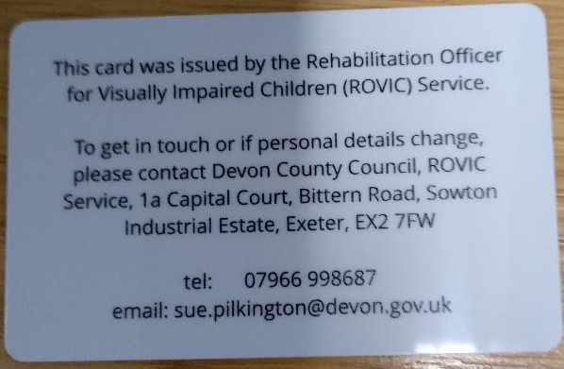

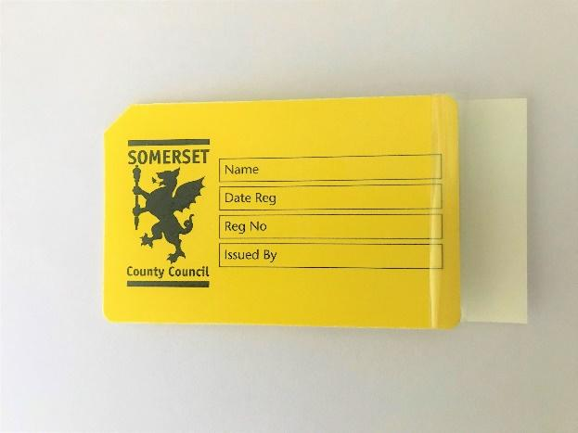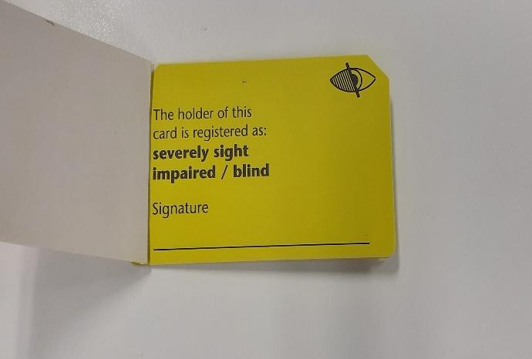

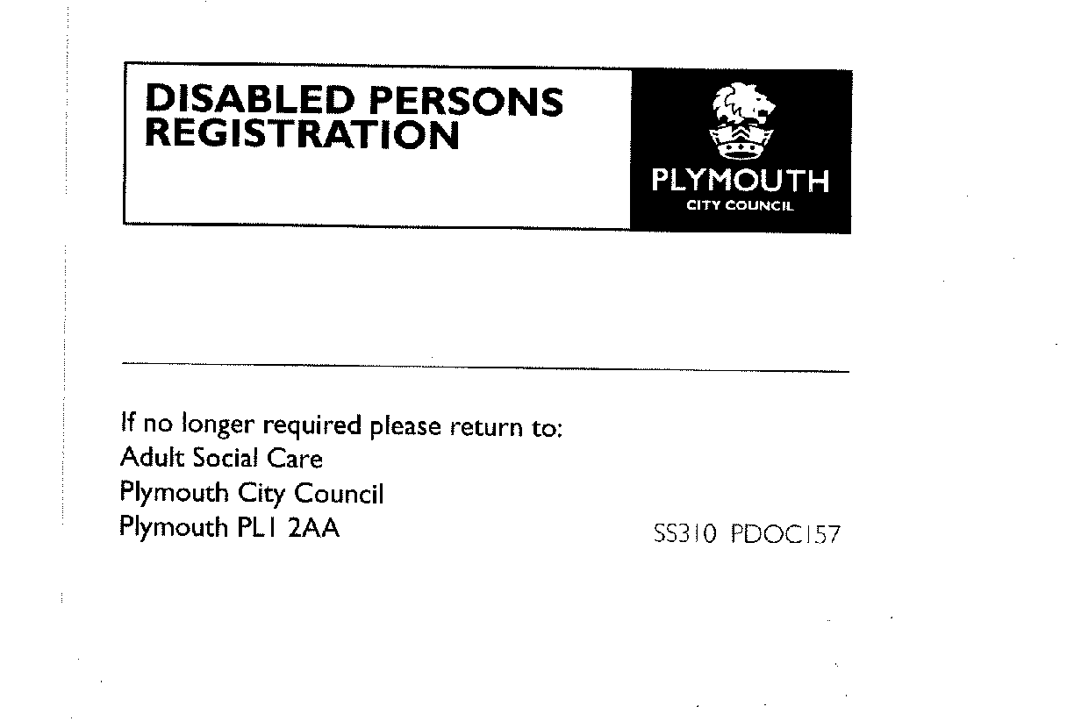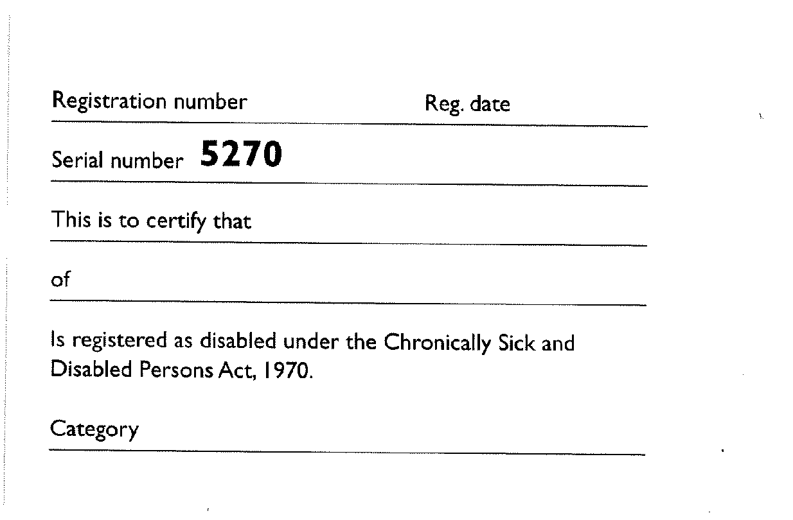
The Royal National Institute of Blind People (RNIB) were producing a CVI card for purchase but have now stopped it and instead have issued a one sided template for Local Authorities to produce. Please see below
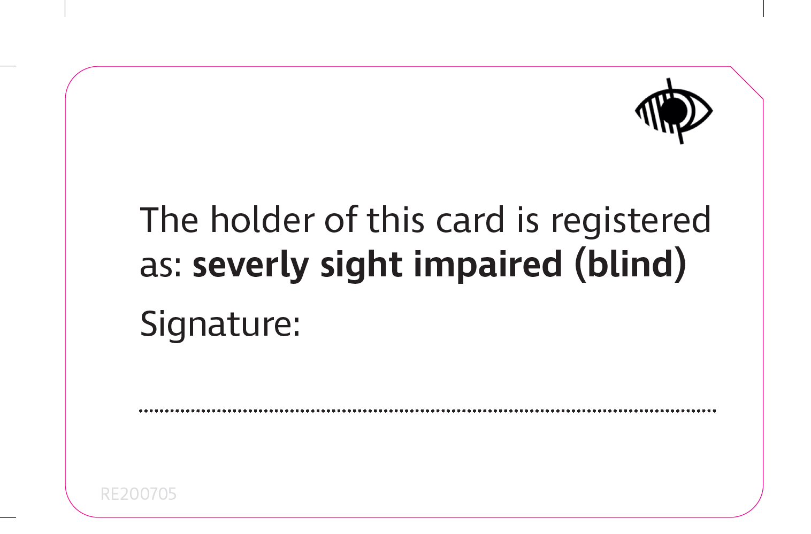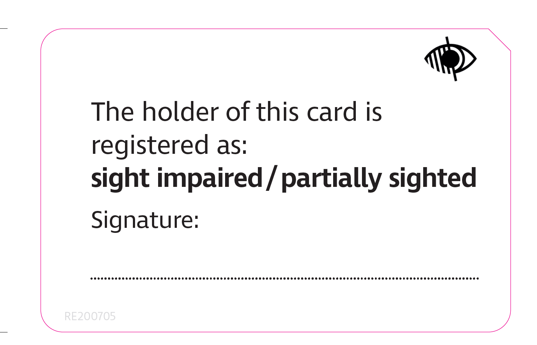
The CVI guidance makes clear the link between the offer of registration, the opportunity to assess someone’s needs and the opportunity to receive rehabilitation or habilitation input from the local authority (or its representatives). RNIB’s “10 Principles of Good Practice” along with (in England) ADASS’s 2016 Position Statement on Vision Rehabilitation and the 2014 Care Act, re-enforce this.
Confirmation of registration on letter headed paper
We are aware that some local authorities will issue a statement, upon individual request, on letter headed paper that confirms registration status. We believe that, whilst helpful to some extent, this is a poor substitute for a registration card because requirement for proof of registration is not infrequent and A4 sized paper does not fit in a wallet and the wear-and-tear will require local authorities to waste time and resource in producing a letter every time a request is made by an individual.
Scotland
In 2018, the Scottish Government introduced the new Certificate of Vision Impairment (CVI) Scotland form. This replaces the BP1 form. However, the CVI form does not include children and young people under the age of 16 years. RWPN is aware that some local authorities in Scotland are providing registration cards and we believe there is no reason why this provision should exist across all local authorities.

Useful Links
10 Principles of Good Practice in Vision Rehabilitation (rnib.org.uk)
https://www.adass.org.uk/adass-position-statement-on-vision-rehabilitation-may-2016
Department of Health (2017) Certificate of Vision Impairment Explanatory Notes for Consultant Ophthalmologists and Hospital Eye Clinic Staff in England https://assets.publishing.service.gov.uk/government/uploads/system/uploads/attachment_data/file/637590/CVI_guidance.pdf

