Handout- Creating a Siri shortcut

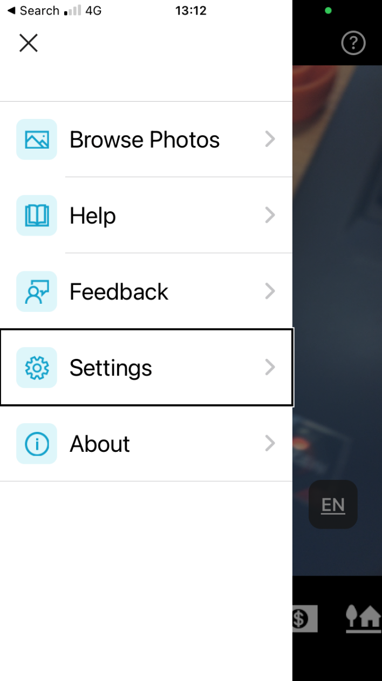

Step 1- Press menu button in top left hand corner of Seeing AI.

Step 2- Navigate down the page to settings and select

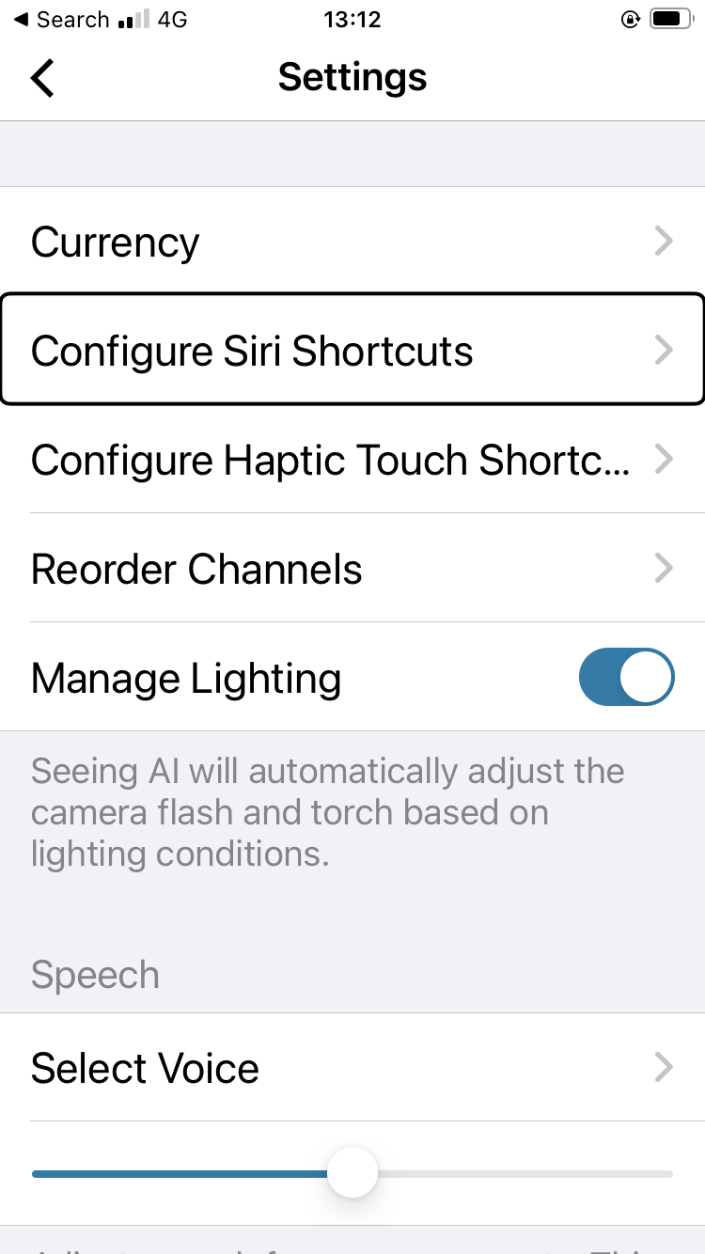

Step 3- Navigate down the page to configure Siri shortcuts and select

Screenshot of seeing Ai in the Siri shortcut for recognising a document. Change 
voice phrase highlighted 

Step 4- Navigate down the page to change voice phrase and select it.

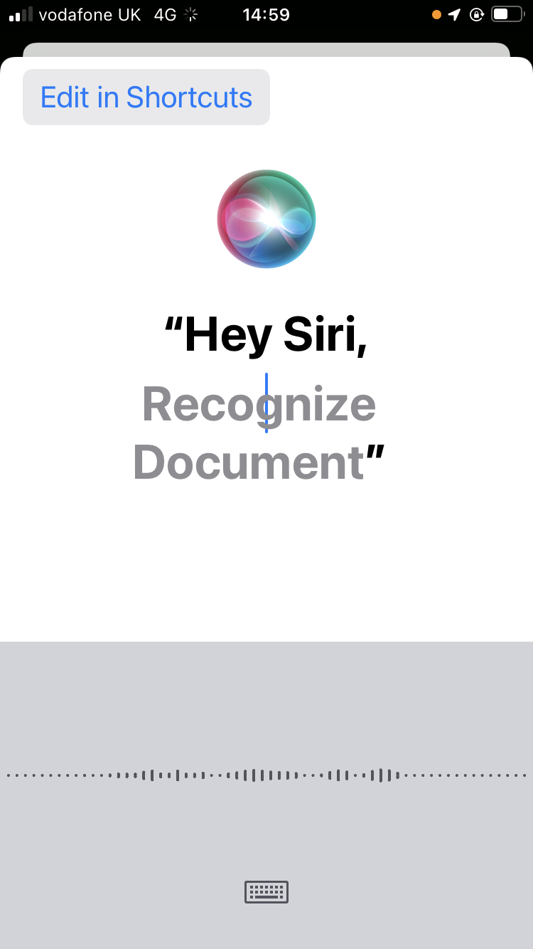

Step 5 After clicking change voice phrase this then be listening for a new phrase to be used for example “recognise document”.

Step 6- Then say “hey Siri recognise document” or manually wake Siri through pressing button associated with Siri and this should open on the correct setting ready to scan for a document