RWPN survey of registrants’ confidence in teaching
solutions that use phones and tablets
Response rate: 107 responses out of 390 (27.5%). This is a large enough response rate to draw some initial conclusions.
These were the five tasks we asked you about
Task 1: Teach a person with low vision how to access and then use low vision settings (e.g. enlarging fonts, contrast settings or magnifier) on their smartdevice (e.g. phone, tablet or PC)
Task 2: Teach a person with little or no useful vision to use basic gestures to operate VoiceOver on iOS (or Android equivalent)
Task 3: Teach a person to use navigation apps on their phone to enable them to undertake a route (assuming they already have good O&M skills)
Task 4: Teach a person with little or no useful vision to scan a document or object using a phone-based app
Task 5: Teach a person to use voice commands to operate their phone, tablet or wifi-enabled devices
Each task was rated at 4 levels, two generally unconfident, two generally confident.
Results
The teaching tasks with lowest levels of confidence were: 1st O&M navigation (68% unconfident) 2nd speech output (64%) 3rd using voice command (57%) 4th scanning (53%) 5th low vision (46%)
The teaching tasks with the greatest levels of confidence or fluency were: 1st low vision (56% confident) 2nd scanning (46%) 3rd voice command (42%) 4th using speech output (36%) 5th O&M navigation (26%)
Date of qualification
Of those who said they were in the two least confident categories, 72% of them qualified before 2014. Of those who said they were in the least confident category, the figure rises to 82% who qualified before 2014. The 2014 date was chosen as a point when IT was being more systematically taught when qualifying.
Access to devices for demonstration
Because this question produced answers that are hard describe in words, we have included a bar chart below.
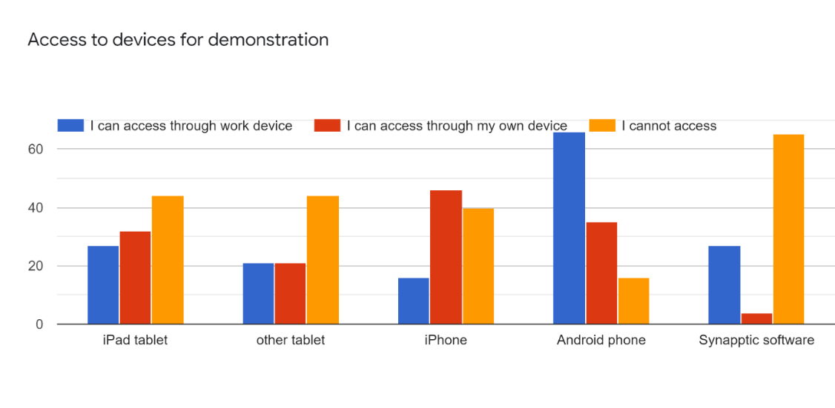
Access to Synapptic was the largest single tech barrier. However, both iPads and iPhones were harder to access than Android, with a significant number having to use their own devices (where they have them). This result is probably because most local authorities provide their staff with Android devices. Of those who said they couldn’t access an iOS device, 35% of them had answered in the bottom two categories of confidence to the five tasks. It may be possible to conclude that lack of access to iOS devices is a factor in lack of confidence.
Personal experience of vision impairment or blindness
12% of the respondents stated they had a visual impairment. The percentage of vi respondents who said they were lacking in confidence to teach the tasks was a lower percentage than for sighted respondents, with the exception of task one (the low vision task). The numbers in this case are probably too low to draw any firm conclusions.
Attitude to teaching IT
The four options we gave you to identify with were:
- I can appreciate the real benefits of technology but I feel left behind. This makes me feel frustrated and not doing the best I can for my clients.
- I can appreciate the real benefits of technology for blind and partially sighted people and I feel left behind. However, this doesn’t frustrate me that much because I am able to support people in other ways.
- I can really see the benefits of the technology for clients. I do want to teach it as much as I can because it is part of the job but lack the confidence and feel frustrated I can’t do this as well as I would like.
- It is an essential part of the role and I will incorporate it into my teaching strategies as a matter of course, provided the client is willing and able.

One in 5 of respondents said they were already confident, and basically getting on with incorporating it into practice regularly. The single largest group (56%) were very positive about tech, wanted to be able to do more but felt they needed more training. This, too, is an encouraging figure because it indicates a real willingness to find out more. The most striking category, and one which would probably need further investigation, is the 15% if respondents who said they felt a bit left behind, but who felt they have other skills to offer; whether this means that because they have other skills to offer, teaching IT is less of a pressing CPD issue, it is hard to know. Here is the result expressed as a pie chart.
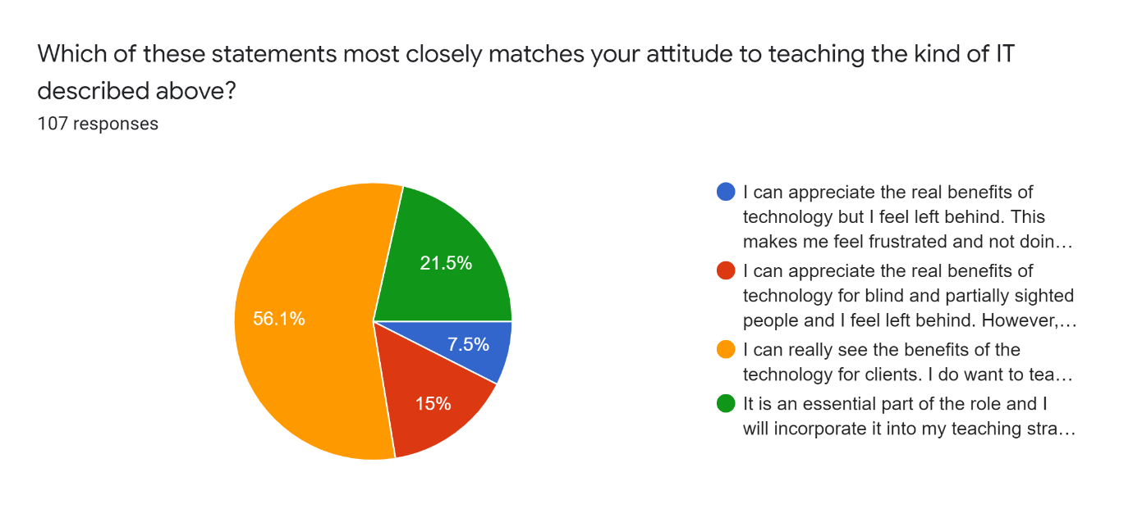

Commentary
There is digital divide in society: there are those who feel comfortable using technology to make life easier or to connect with people, and there are those who do not feel fully comfortable with technology or do not have access to it. As members of society Vision Rehab and Hab Specialists are, to some extent, no different in experiencing this division. However, if we take as a starting point the proposition that IT solutions have the ability to help visually impaired and deafblind people meet everyday needs and connect with people, then we must ask ourselves: at what point are the limitations of the workforce increasing this digital divide for the people we support? Our role is as enablers and teachers. Are we performing our duties to the best of our abilities? Teaching an O&M app (as part of wider O&M skills) is a skill that our profession, and no other, can really undertake.
There is clearly an appetite amongst the workforce to become more confident, but for some, getting access to all platforms is a definitely a barrier. Whilst we can do little about the access issue, and it cannot be ignored, RWPN can look at what training is out there and work with other providers to create or extend opportunities for everyone to gain confidence.

October 2021

