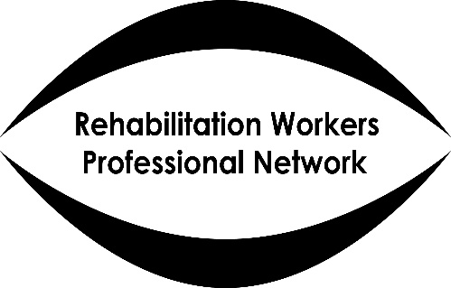

RWPN Rehabilitation Worker Scottish Conference
September 19th 2019
Scottish War Blinded Hawkhead Centre, Paisley

9.30 Coffee and Tea

10.15 Welcome and Opening Remarks: Rebecca Barr, Head of SWB & Simon Labbett, Chair of RWPN

10.25 Rehabilitation in the Policy Context of See Hear
Jonathan Reid, The Alliance

10.45 Wheelchair Mobility – introductory comments
Angie Bisson Royal Blind School

11.00 - 11.20 Coffee break

11.20 - 12.20 Workshops (choose one from three)

- Wheelchair Mobility – Rehab and how to work with VI wheelchair users and importance of promoting independence to aid orientation - a practical session. Angie Bisson, Royal Blind School (places will be limited)

- Accessible tech with sightloss – Triple Tap Tech’s experts will guide you through some of the vast range of digital devices and apps that can be very helpful to people with visual impairment

- Charles Bonnet Syndrome – Judith Potts, Esme’s Umbrella

12.20 - 13.30 Lunch
(optional session 13.00-13.30 – Exploring the support needs of former GCU students in professional practice. Katrina Campbell, Scottish War Blinded and GCU tutor)

13.30 -14.30 Repeat of morning workshops (choose one of the remaining two from the list above)

14.40 Emotional Support and Sight loss – exploring the role of Rehab Officers in the process - Mhairi Thurston, Programme Leader for MSc Counselling, Abertay University
15.20 Ensuring a future for the profession in Scotland. What we will do/what you need to do - Simon Labbett & Norma Baillie RWPN

15.35 Close

