Microsoft Soundscape Routes Feature Guide

Step 1
In the main window of Soundscape select ‘Markers & Routes’

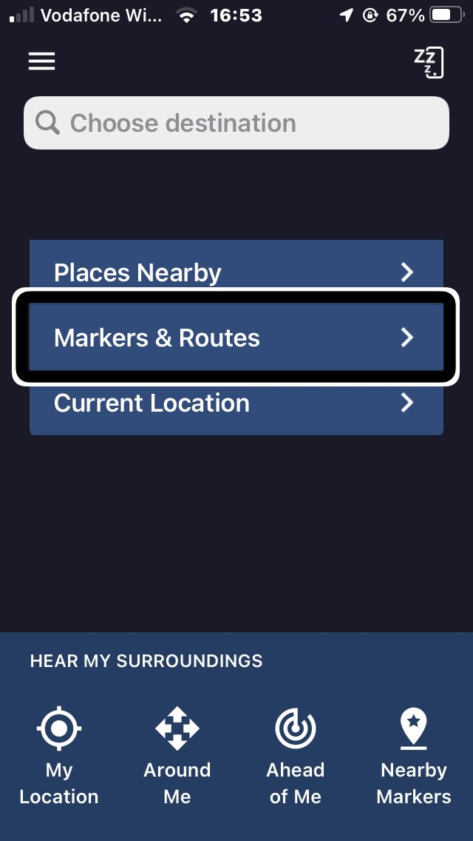

Step 2
Select the ‘Routes’ tab located at the bottom right hand side of the screen.
Step 3
Select the + ‘New Route’ button
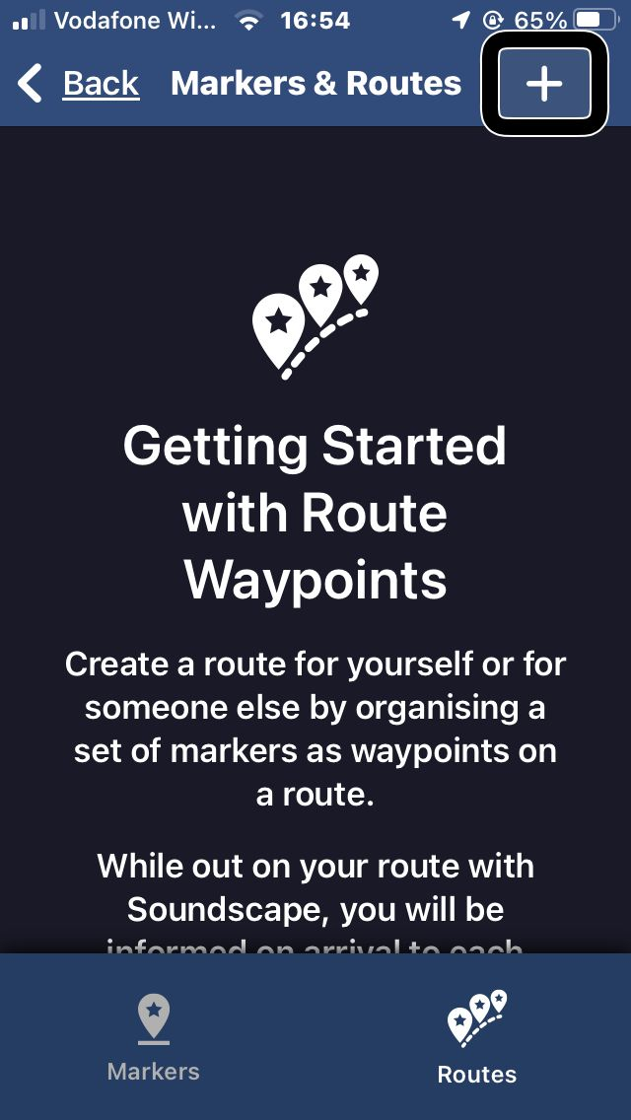

Step 4
Enter the Name and describe your route
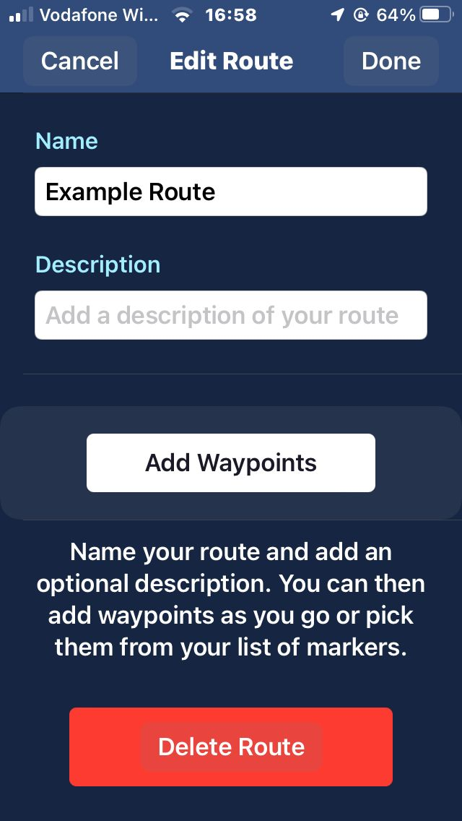
Step 5
Select ’Add Waypoints’ button

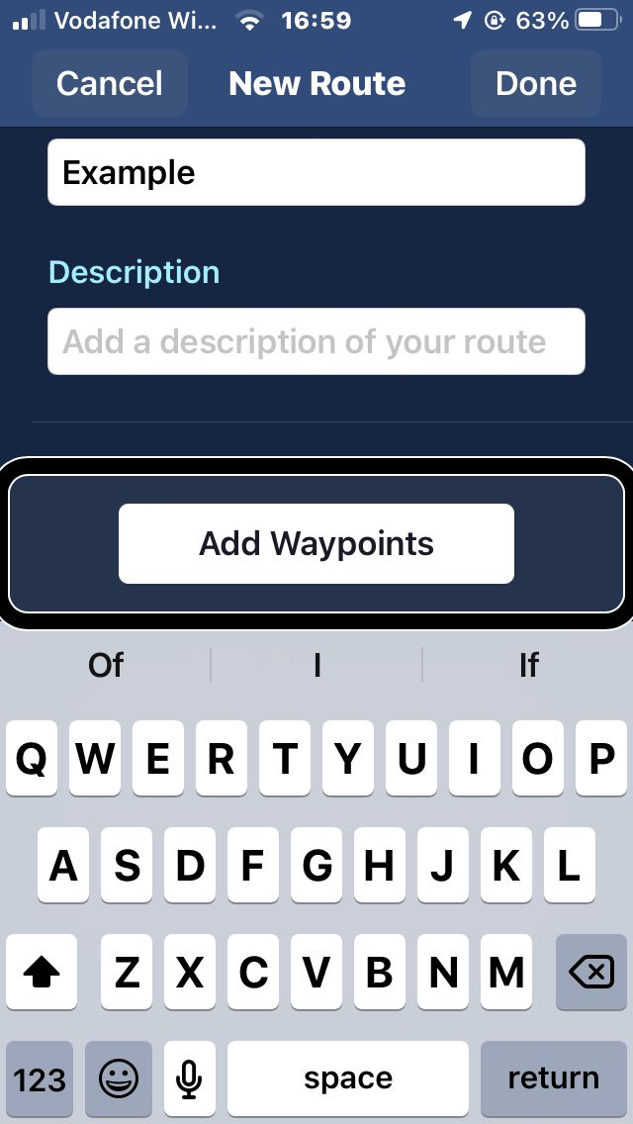
Step 6
Select either ‘Places Nearby’, your ‘Current Location’, or a ‘Marker’ you have previously created.
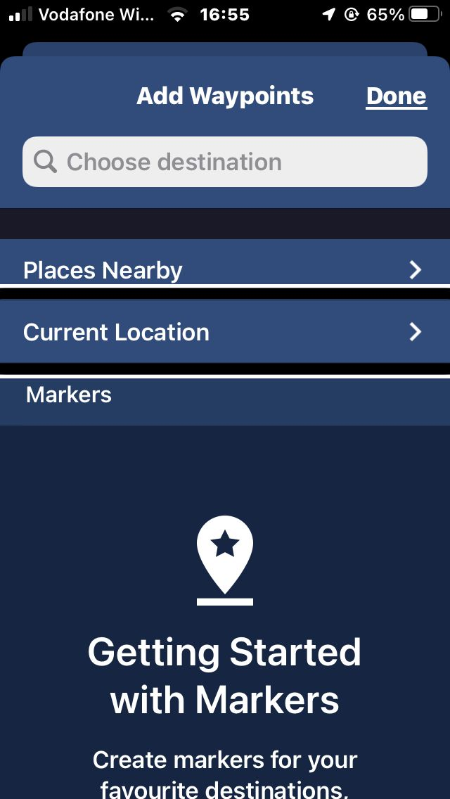
Step 7
Name ‘Marker’ and add an ‘Annotation’ and then select ‘Done’. And then reapeat this for each decision point or lanmark on route.

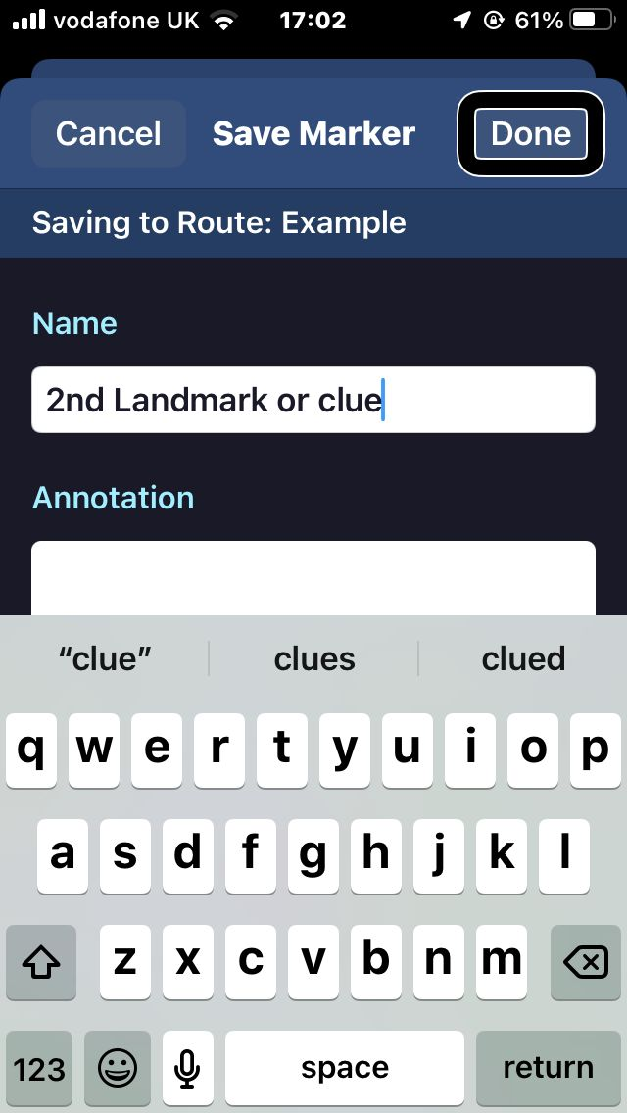
Step 8
To start this route again select the ‘Routes’ tab within ‘Markers and Routes’. Select the ‘Route’ from and then select ‘Start Route’
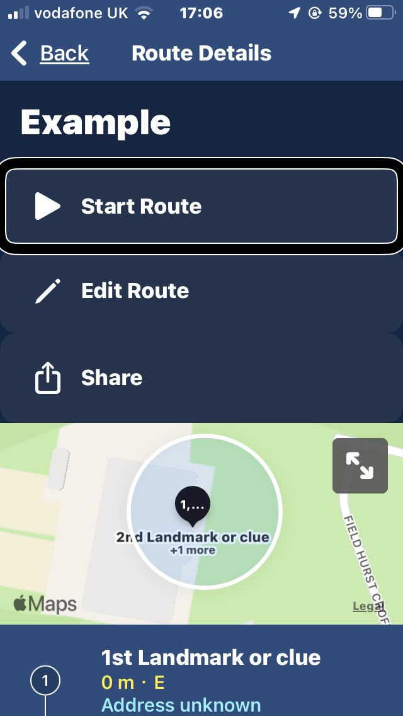

Step 9
To share a route you have created. Select the ’Route’ again, then ‘Share’ followed by ‘Airdrop’. You should then be able to send it to anybody else’s iPhone.
t