Suitable Headphones for Use with Wayfinding Apps for Vision Impaired and Blind Users

Both bone conduction and open ear headphones allow users to receive information through audio, whilst still being able to hear the environment they are in.

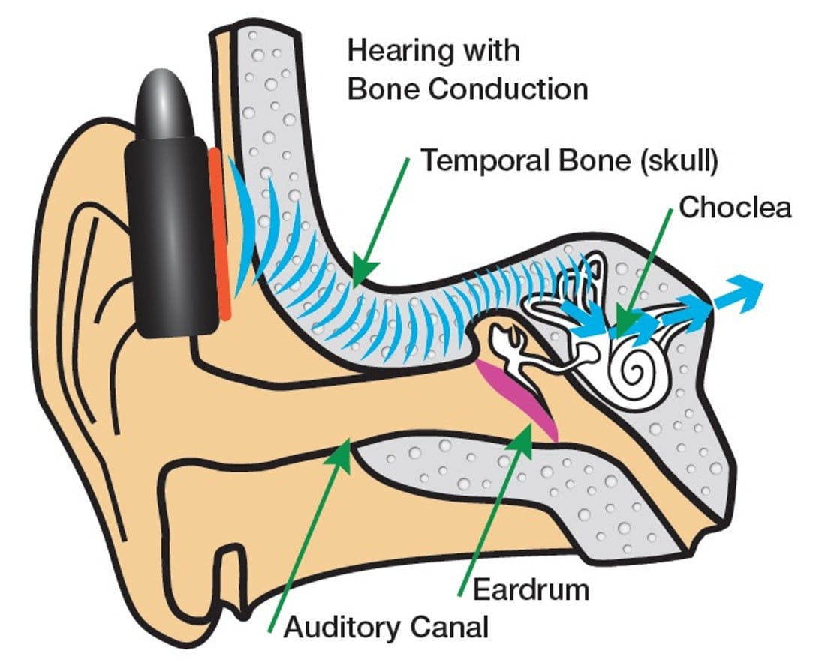

How do they work?
Bone conduction headphones work by having small speakers which sit just underneath each temple through which sound vibrations travel through the temporal bone to the inner ear.

Originally developed in the 70’s for use with hearing aid implants, they are also now used in the military and by lots of runners and cyclists. This is due to users still being able to hear and be aware of their environment. For this reason, a lot of vision impaired and blind people find them beneficial too when using wayfinding apps/ devices.

Open ear headphones work slightly differently and have carefully positioned speakers, which do not block the ear canal and send audio through the air instead of through vibrations. This is a newer technology and headphones usually have headtracking sensors, so that apps or devices can track users direction easily. Currently there are limited options available.

Types
There are currently two main types of bone conduction headphones:
- wireless headphones (Bluetooth)
- wired headphones

Options for open ear devices with head tracking are:
- Bose Frames
- Sony LinkBuds

Cost
Bone conduction and open ear headphones range from around £30 to £200 depending on the type and manufacturer. All of them are fit for purpose but each have their own advantages or disadvantages, such as having longer battery life, being louder, lighter, or having head tracking capabilities, but generally it is down to personal preference which one people prefer.

Considerations
Bone conduction and open ear headphones combined with wayfinding apps/ devices are not suitable for all clients. The additional information provided through them may be counterproductive and/ or overwhelming for some clients. A thorough assessment should be carried out before issuing/ advising to purchase.

Tips
- With bone conduction users can easily access Siri to use voice commands, such as Microsoft Soundscape features
- Open ear devices tend to have better spatial audio capabilities
- Can be used during mobility training with clients to aid communication at a distance or in busy environments
- Users can easily answer and end calls
- Wired headphones are usually the loudest option

